**Federal Interest Determination**

**Continuing Authority Feasibility Investigation**

**Section 204 Beneficial Uses of Dredged Material**

**Cedar Island, Virginia**

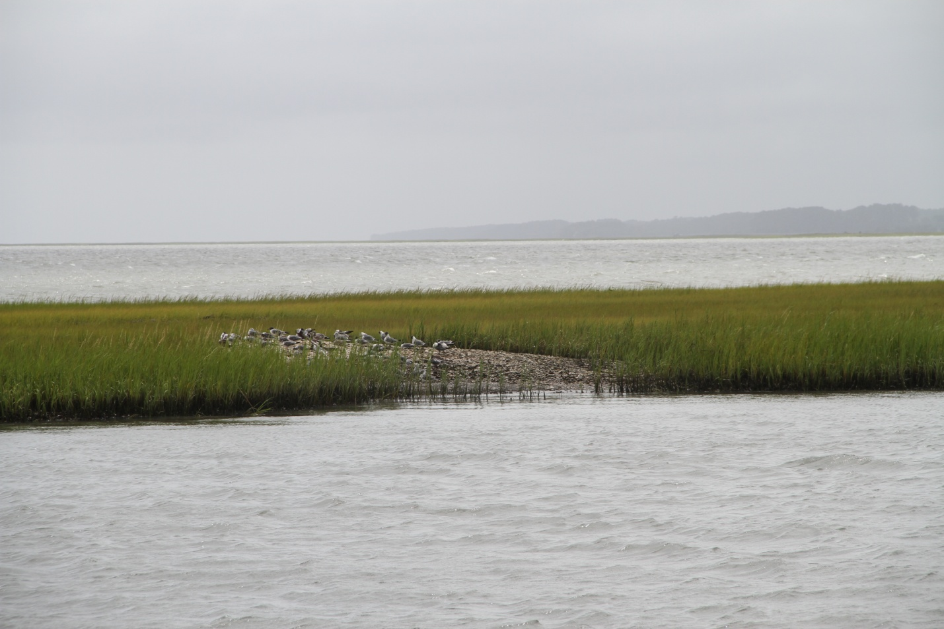

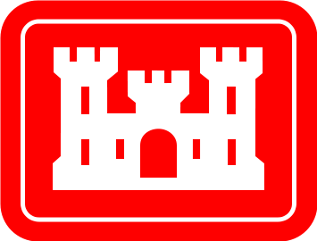

U.S. Army Corps of Engineers, Norfolk District

803 Front Street

Norfolk, Virginia 23510

February 2016

Table of Contents

1.0 Project Name 3

2.0 Congressional District and Sponsor 3

2.1 Congressional District 3

2.2 Sponsor 3

3.0 Project Location 3

4.0 Authority Requirements 5

5.0 Project Purpose, Problems, and Needs 5

6.0 Intracoastal Waterway Navigation Channels 8

7.0 Without Project Condition 8

8.0 With Project Condition 8

9.0 Cost Estimate 11

10.0 Project Benefits and Justification 12

11.0 Other Considerations 13

11.1 Real Estate 13

11.2 Environmental/Cultural 13

11.2.1 Magnuson-Stevens Fishery and Conservation Management Act (Essential Fish Habitat) 13

11.2.2 Historic Properties 13

11.2.3 Endangered Species Act 13

11.2.4 Previous Coordination 13

12.0 Sponsorship 14

13.0 Recommendation 14

14.0 Schedule 14

15.0 References 15

# Project Name

Cedar Island, Virginia, Beneficial Uses of Dredged Material.

# Congressional District and Sponsor

## Congressional District

Virginia – Second District (Representative Edward “Scott” Rigell)

## Sponsor

The anticipated non-federal sponsor for the project is the Virginia Marine Resources Commission. Land ownership in the project site areas is maintained as a public trust by the Commonwealth of Virginia and managed by the Virginia Marine Resources Commission.

# Project Location

Cedar Island is a barrier island located within the Delmarva Peninsula in the Virginia Coast Reserve, the largest expanse of protected coastal habitat in the United States (Figure 1). Cedar Island is located centrally within the barrier island chain with the Metompkin Inlet separating Cedar Island from Metompkin Island to the north and the Wachapreague Inlet separating Cedar Island from Parramore Island to the south (Figure 1). The western side of Cedar Island (referred to as the back-barrier) is flanked by channels, tidal wetlands and marsh islands, lagoons, and mudflats. The Atlantic (eastern) side of Cedar Island is comprised of beach and dune habitat and relict tidal wetlands. The coastal mainland Town of Wachapreague is located on the mainland, west of the Cedar Island back-barrier (Figure 1).

Virginia’s barrier islands (and associated back-barrier channels, tidal wetlands and marsh islands, lagoons, and mudflats) are the most pristine stretch of barrier islands in the Atlantic coastal region, providing some of the most significant ecological habitat along the Atlantic Coast. The Virginia barrier islands are the most productive chain of barrier islands for nesting and foraging colonial and shorebird species in the Mid-Atlantic Region (Wilson et al. 2007). The inlets and channels provide nursery habitat for juvenile loggerhead and Atlantic ridley sea turtles (Priest et al. 1986). Tidal wetland marshes and marsh islands, channels, and lagoons provide crucial migratory and nursery habitat to valuable commercial and sport fisheries such as red drum, seatrout, summer flounder, and striped bass. Approximately 95% of Virginia’s annual harvest of commercial and sport finfish from tidal waters is dependent on wetlands (Virginia Institute of Marine Science (VIMS) 2015). Intertidal and subtidal oyster reefs and mudflats are abundant in the back-barrier. The Cedar Island back-barrier contains productive oyster harvesting grounds. Oysters play a key role in the ecosystem, serving to improve water quality with their filtration capacity as well as providing foraging and/or sheltering habitat for a multitude of resources including finfish, crabs and other invertebrates, and avian predators. Oyster reefs can also provide shoreline protection to adjacent shorelines. Submerged Aquatic Vegetation (SAV) is prolific in the back-barrier, providing sheltering and foraging habitat to a diverse array of finfish and invertebrates. The back-barrier tidal wetland areas provide other critical ecosystem functions such as improving water quality and sequestering carbon. The tidal marshes function to remove pollutants and serve as a sediment trap for upland runoff and from the adjacent tidal creeks, serving to reduce turbidity and siltation of shellfish beds, SAV, and navigation channels (VIMS 2015). Tidal marshes fix an estimated four metric tons of carbon per hectare/year with an average range of 0.4 – 2.4 metric tons per hectare/year (VIMS 2015), helping ameliorate climate change, which is induced mainly by fossil-fuel burning related carbon emissions. This high level of productivity in the Cedar Island back-barrier forms the basis of the estuarine and marine food web pathways for species such as blue crabs, shellfish, and finfish.

Oysters and wetlands not only play an essential role in improving water quality and in building estuarine food webs, but also play a critical role in stabilizing and accreting sediment and providing natural shoreline protection. Cedar Island has historically buffered the Town of Wachapreague from storm events and long-term shoreline erosion threats. Wachapreague is primarily a recreational fishing town with an estimated population of 232 (USA City Facts 2015).



**Figure 1. Study Area in the Delmarva Peninsula depicting Cedar Island, the authorized federal navigation channels in the Cedar Island back-barrier (blue), and existing dredged material placement site in Bradford Bay (orange). The authorized federal navigation channel south of Bradford Bay is not shown. Vicinity map provided courtesy of Messmore (2012).**

# Authority Requirements

The Water Resources Development Act of 1992, Continuing Authorities Program Section 204, provides authority for the U.S. Army Corps of Engineers (USACE) to beneficially use material dredged from authorized federal navigational channels for the protection, restoration, and creation of aquatic and related habitats. The Section 204 authority can be applied for construction and/or maintenance dredging of authorized federal navigation channels.

The cost of a dredged material beneficial use project must be economically justified by damaged prevented or ecosystem restoration benefits realized. The non-federal cost share for projects conducted under the Section 204 program is based on the cost of the federal standard. The USACE places dredged material from federal navigation projects in the least costly manner in accordance with sound engineering practices and compliance with federal, state, and local regulatory requirements. The plan that meets these requirements constitutes the federal standard. If the federal standard (least cost alternative) includes the placement of dredged material in a manner beneficial to the environment, the costs for this use are included in total costs of the project and funded accordingly. Where the beneficial use of dredged material is not part of a federal standard for the navigation purpose, the federal standard serves as a reference point for determining the incremental costs that are shared by the non-federal sponsor. Only the additional cost in excess of the federal standard is cost shared. A non-federal sponsor is required to contribute 35% of the incremental costs for the beneficial use(s) of the dredged material above the cost of the federal standard. The federal cost limit for a Section 204 project is $10 million.

# Project Purpose, Problems, and Needs

Federal navigation channels authorized for dredging in the Cedar Island back-barrier include the Cedar Island Bay Channel, Burtons Bay Channel, Finney Creek Channel, and the Bradford Bay Channel (Figure 1). Currently there is one active dredged material, open-water placement site for these navigation channels that is located in Bradford Bay (Figure 1).

Cedar Island is a mixed-energy, tide-dominated barrier island (Richardson 2012; Wilson et al. 2007; Figure 1). Unlike other barrier islands, it lacks a substantial offshore sand supply and lacks near-shore sand bars. Cedar Island is in an accelerated rate of shoreline retreat characterized by rapid barrier island rollover and landward migration (Richardson 2012). Richardson (2012) estimated the retreat as –5.5 meters/year over the long term (1852-2007) and –15.4 meters/year over the short term (2007-2010) (Figure 2). The increased frequency of storms and hurricanes and magnitude of such events is thought to be linked to the increased shoreline retreat of Cedar Island in more recent years (Richardson 2012).

**Figure 2. Estimated shoreline changes from 1852-2010 showing Cedar Island shoreline retreat (Figure courtesy of Richardson (2012)).**

Cedar Island is predicted to continue to narrow and fragment (Richardson 2012). Cedar Island has breached in multiple areas including adjacent to the U. S. Coast Guard Base, indicating the island is fragmenting (Richardson 2012). Loss of Atlantic coastal portions of Cedar Island is anticipated to increase erosion and storm effects to the Cedar Island back-barrier and potentially impact the Wachapreague mainland.

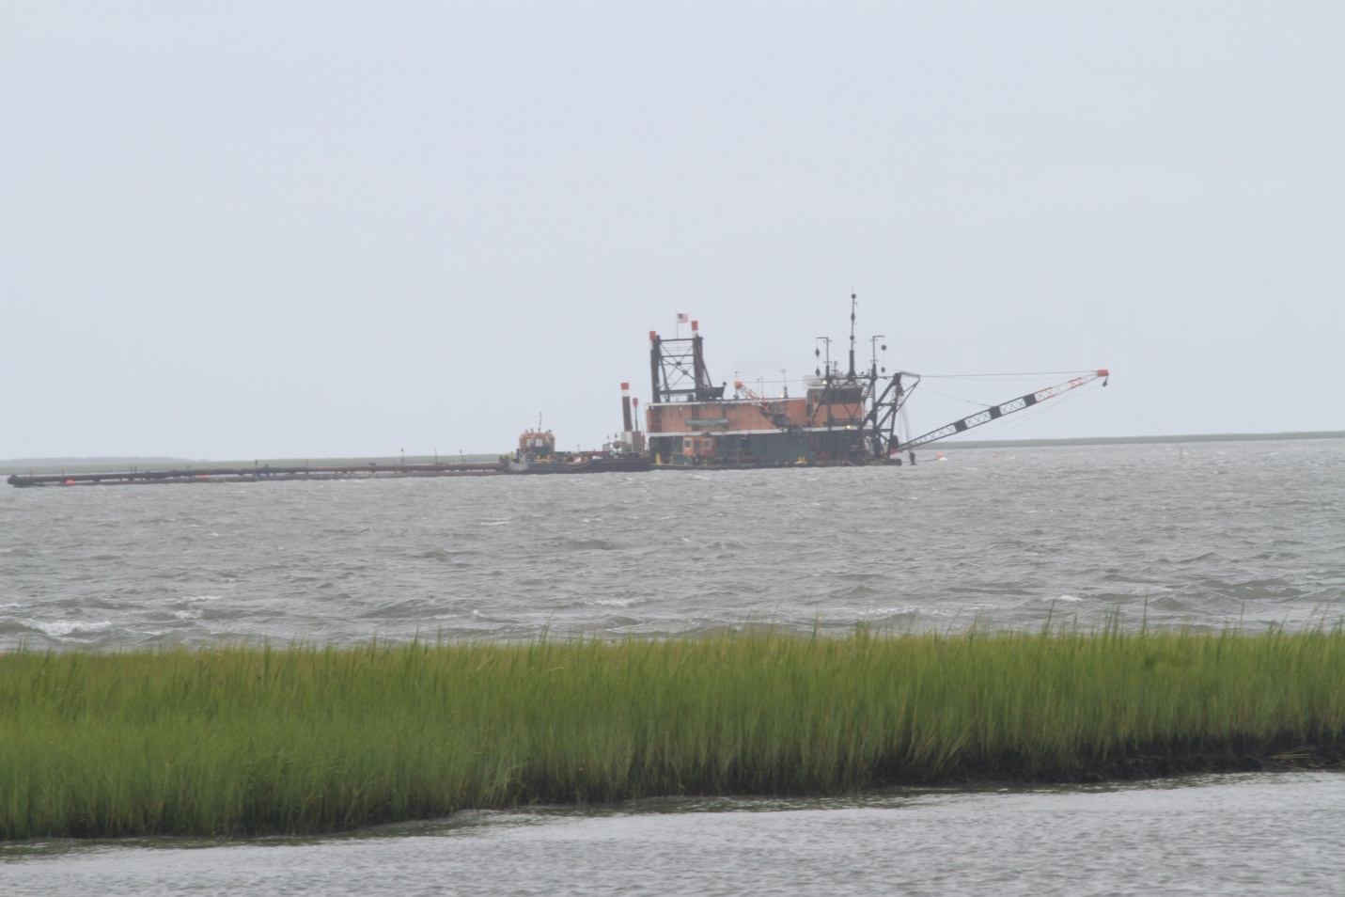Along the shoreline of Wachapreague in the tidal wetland shoreline, marsh islands, channels and lagoons of Bradford Bay, the existing saltmarsh cordgrass-(*Spartina alterniflora*) dominated wetlands and marsh islands are subsiding and subject to rapid erosion rates (Figure 3).

**Figure 3. Cordgrass-dominated marsh island in the Cedar Island back-barrier showing lack of erosion protection and evidence of subsidence.**

Based on a GIS analysis conducted in the Cedar Island back-barrier, Erwin et al. (2004) estimated a 9% loss of tidal wetlands in a study site in the Cedar Island back-barrier during the 1949 – 1994 time period. Loss of shoreline wetland and marsh island habitat is the result of long-term natural and anthropogenic processes that occur at local and regional levels coupled with sea level rise impacts. Wetland erosion results from synergistic sources including storm events, tidal currents, and wave energy. The sediment grain size in the Cedar back-barrier channels is generally characterized as a fine, silt-dominated composition (50.2 - 52.0% silt; 31.8 – 38.2% clay; and 9.8 – 18.0% sand) (Priest et al. 1996). The continuing erosion threats coupled with the silt-dominated sediment composition places the back-barrier tidal shoreline wetlands and marsh islands at risk of fragmentation, and ultimately, loss. Land subsidence and wetland loss is anticipated to increase in response to sea level rise placing the tidal wetland marsh interface between the Delmarva barrier islands on the east and the mainland Town of Wachapreague flanking on the west at extreme risk of continued degradation, and ultimately loss.

The primary purpose of the project is to beneficially use the dredged material from the Cedar Island Bay Channel, Burtons Bay Channel, Finney Creek Channel, and the Bradford Bay Channel for enhancement, expansion, and protection of the Cedar Island back-barrier shoreline wetlands and marsh islands. Dredged material from other authorized federal navigation channels in the Waterway on the Coast of Virginia may also be considered for use to achieve the goals and objectives of this project. Key objectives of the project that would be considered in the feasibility study would be to achieve the following in the Cedar Island back-barrier:

* Reduce the current rate of tidal wetland shoreline and marsh island degradation and loss;
* Expand and enhance the existing wetlands and marsh islands to enhance fish habitat, fishery resources, and wildlife habitat;
* Increase the area of intertidal mudflat habitat to provide increased foraging opportunities for avian fauna;
* Incorporate hard-bottom reef habitat with wetland enhancement and creation sites as a long-term, sustainable solution to reduce tidal wetland erosion rates, increase sediment accretion rates, and increase shoreline protection;
* Create more suitable wetland elevations for shoreline tidal wetlands and marsh islands to provide more suitable tidal inundation ranges for a cordgrass-dominated vegetation community;
* Enhance existing shoreline protection to the Town of Wachapreague through wetland and marsh island creation, enhancement, and protection; and
* Adaptively manage the dredged material environmental use project sites in response to the constantly fluxing ecosystem that is under the continual threats such of erosion, subsidence, and sea level rise.

This project will serve to reduce coastal erosion rates and provide shoreline protection benefits to the Town of Wachapreague. The community of the Town of Wachapreague has expressed an interest and has vetted support for beneficial dredged material use projects that will provide environmental benefits and allow for shoreline protection and enhancement. The proposed project also has important implications for future natural resource management for how to adaptively manage and mitigate the effects of sea-level rise on tidal wetland complexes in the barrier island Delmarva complex and potentially, across the Atlantic coastal regions.

The purpose of this Federal Interest Determination is to determine whether beneficial uses of the dredged material would provide sufficient benefits to demonstrate a federal interest in pursuing a cost-shared feasibility study with the non-federal sponsor. Federal interest is determined by comparing the incremental cost of the dredged material beneficial use project as compared to the overall public benefit.

# Intracoastal Waterway Navigation Channels

The U.S. Army Corps of Engineers dredges federal navigation channels throughout the Waterway on the Coast of Virginia. Federal navigation channels authorized for dredging in the Cedar Island back-barrier are the Cedar Island Bay Channel, Burtons Bay Channel, Finney Creek Channel, and the Bradford Bay Channel (Figure 1). Dredged materials are pumped into Bradford Bay at one active, open-water placement site (Figure 1). Federal navigation channel dredging sites and placement areas are also located north and south of these sites.

# Without Project Condition

The existing and future without project condition would be to continue open-water dredged material placement in the permitted placement site that is located in Bradford Bay (Figure 1).

# With Project Condition

The proposed conceptual project consists of three beneficial dredged material use sites that are described below and are depicted in Figure 4 (Sites 1 – 3). During the feasibility phase, additional project alternatives will be formulated and evaluated that will consist of individual measures as well as various combinations of measures that comprise the proposed conceptual project. During the feasibility phase, project stakeholders may present other measures and project alternatives that will be considered as well. Figure 4 is meant to represent the estimated project sites; the actual size and locations of project sites may vary depending on the final project design and constraints. Figure 5 depicts natural salt marsh zonation that will be used as the conceptual model for construction and adaptive management of beneficial use Sites 2 - 3. Figure 6 provides an example of salt marsh zonation in Virginia from subtidal habitats to cordgrass-dominated habitat (high marsh habitat is not shown).

The conceptual project would allow an approximate 50-year dredged material placement period with placement periods occurring approximately twice every 10 years. Where feasible, the components would be implemented in an incremental approach so that ecological and shoreline benefits could be accrued in the shortest timeline possible. The conceptual components of the proposed project would consist of the following:

* Site 1 - Conduct thin layer placement of dredged material to the marsh island adjacent to the navigation channel parallel to the Wachapreague Marina/Atlantic Avenue (Figure 4, Site 1) to achieve a more suitable elevation for a cordgrass-dominated vegetation community. Thin layer placement consists of spraying dredged material (sediment) slurry under high pressure over the marsh island. Marsh islands are adapted to respond to natural sediment deposition processes, such as storms and tidal fluxes, and thin layer deposition would mimic this natural process, allowing for more suitable marsh island elevations.
* Site 2 - Conduct thin layer placement of dredged material over the existing shoreline tidal wetlands along the western edge of Bradford Bay to achieve a more suitable elevation for a cordgrass-dominated vegetation community (Figure 4, Site 2). Construct saltmarsh wetlands, intertidal mudflat habitat, and a fringing, hard bottom reef along the western shoreline flanking Bradford Bay. Construct tidal wetlands and mudflats to mimic conceptual salt marsh zonation (Figures 5 -6).
* Site 3 - Construct saltmarsh wetlands, intertidal mudflat habitat, and a fringing, hard bottom reef along the largest southern extent of remaining tidal marsh islands adjacent to the Atlantic coastal portion of Cedar Island. (Figure 4, Site 3). Construct tidal wetlands and mudflats to mimic conceptual salt marsh zonation (Figures 5 -6).

After target sediment elevation is reached at the wetland construction sites, native salt marsh vegetation (cordgrass-dominated community) would be planted to help stabilize the sediments, promote native vegetation growth, and provide wildlife habitat. Each following year (until site stabilization), an inspection of the wetland thin layer placement sites and construction sites by a qualified wetland biologist would be conducted to assess wetland vegetation species composition, vegetation density, and growth rates and to provide recommendations for adaptive management actions, if necessary (e.g. add/remove sediment to maintain elevation targets, remove invasive vegetation, etc.). Project construction and wetland planting activities would be carefully planned to avoid impacts to natural resources, notably protected species and other species of management concern and their habitats (for example, migratory and nesting avian species).

The fringe reef habitat could be constructed from native oyster shells, artificial substrate, or from a combination of shells and artificial substrate. Artificial substrates, such as granite or concrete, would provide more substantial shoreline protection than loose shell substrate. Another potential option would be the use of loose shell bags and/or shell mats. We would anticipate that natural oyster recruitment would occur on the constructed reef habitat. During this initial site selection, we avoided selecting areas that are currently leased for oyster harvesting so as not to impact harvesting operations. Impacts to existing oyster clusters and reefs and SAV that occur in project site areas will be avoided to the maximum practical extent. Oyster cluster and reef data and SAV survey data will be reviewed prior to site final selection to avoid impacts to these resources if possible. Submerged aquatic vegetation will be relocated to other sites in the immediate vicinity where there is existing SAV habitat and suitable physical conditions as a last resort if impacts cannot be avoided and conditions in nearby sites are suitable for SAV relocation. Oyster clusters and reefs will be preserved and incorporated into the project design to the maximum practical extent if impacts cannot be avoided. The results of cultural resources investigation(s) will also be used as a factor for selection of the project sites such to avoid negative impacts to cultural resources.



**Figure 4. Proposed locations for beneficial dredged material use sites (Sites 1 – 3) in the Cedar Island back-barrier. Vicinity map provided courtesy of Messmore (2012).**

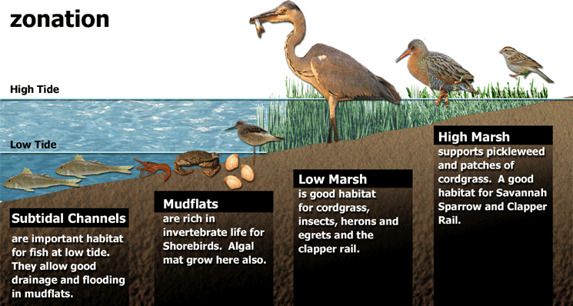

**Figure 5. Conceptual zonation of natural saltmarsh habits (figure courtesy of http://www.amigosdebolsachica.org/images/zonation_large.gif). For proposed project Sites 2-3, tidal wetland and mudflat habitats will be constructed to mimic natural salt marsh zonation. For proposed project Sites 2-3, a fringe oyster reef will be constructed in the subtidal zone (not shown).**

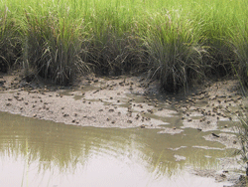

**Figure 6. Salt marsh zonation from subtidal habitat to mudflat habitat to cordgrass-dominated salt marsh community, Virginia (courtesy of Matt Mainor, VIMS 2015).**

# Cost Estimate

|  |  |  |  |  |
| --- | --- | --- | --- | --- |
| A summary cost estimate to plan, construct, and adaptively manage the Cedar Island Dredged Material Use Project is provided in Table 1. The total estimated project costs, in excess of current dredging placement costs, that includes project management, development of plans and specifications, construction, as well as monitoring and adaptive management is for an estimated total cost of $9.5 million (Table 1). The total USACE funding responsibility for the project is an estimated $6.1 million and the total non-federal sponsor funding responsibility for the project is an estimated $3.3 million (Table 1). The estimated project management and construction costs were largely based on modified detailed cost estimates from the Lynnhaven River Basin Ecosystem Restoration Project (USACE 2013). However, the cost estimates were adjusted to account for a reduced level of project management anticipated with the Cedar Island Beneficial Uses of Dredged Material Project as well additional inflation and mobilization costs anticipated with the Cedar Island Beneficial Uses of Dredged Material Project.  **Table 1. Summary Cost Estimate for the Cedar Island Beneficial Uses of Dredged Material Project.** |  |  |  |  |
| |  |  |  |  |  | | --- | --- | --- | --- | --- | | Description | Cost ($)/Unit | Unit | No. Units Needed | Total Cost ($) | | Plans and Specifications | $2,000,000 | labor | 1 | $2,000,000 | | Construction Management | $1,000,000 | labor | 1 | $1,000,000 | | Environmental Permitting/Oversight | $10,000 | labor | 10 | $100,000 | | Operations - Labor | $4,000 | day | 200 | $800,000 | | Operations - Boat Maintenance & Operations | $2,500 | day | 200 | $500,000 | | Submerged Aquatic Vegetation and Oyster Relocation | $20,000 | acre | 10 | $200,000 | | Wetland Grading and Planting | $28,000 | acre | 10 | $280,000 | | Thin Layer Spraying of Wetlands | $18,000 | year | 6 | $108,000 | | Reef Habitat | $800,000 | acre | 5 | $4,000,000 | | Project Monitoring and Adaptive Management (Years 5-10) | 10% total project costs | year | 5 | $898,800 | |  |  |  |  |  | | Total Project Costs |  |  |  | **$9,886,800** | | Total Project Costs in Excess of Current Dredged Material Placement Costs |  |  |  | **$9,514,800** | |  |  |  |  |  | |  |  |  | **Federal (65%)** | **$6,184,620** | |  |  |  | **Non-Federal (35%)** | **$3,330,180** | |  |  |  |  |
|  |  |  |  |  |

# Project Benefits and Justification

The beneficial use of dredged material project will provide substantial environmental benefits to the Cedar Island back-barrier ecosystem and enhanced shoreline protection to the Town of Wachapreague. Implementation of the project is anticipated to increase wetland values and functions by enhancing the quality and quantity of shoreline wetlands and marsh islands in the Cedar Island back-barrier. Adaptively managing tidal wetland elevations will provide for a sustainable approach to protect tidal shoreline wetlands and marsh islands in the Cedar Island back-barrier subjected to the continuing threats of erosion, climate change, and sea level rise. Adaptive management of the project sites will allow marsh elevations to be monitored and adjusted to account for local environmental conditions and long term effects of sea level rise, furthering to improve long-term sustainability of the project. Improvement and expansion of the tidal shoreline wetlands and marsh islands will increase the value and quantity of migratory and nursery habitat for valuable commercial and sport fisheries such as clams, oysters, red drum, seatrout, summer flounder, and striped bass. The constructed reef habitat will serve to increase the local, native oyster population, improve water quality, and provide foraging and/or sheltering habitat for a multitude of species including finfish, crabs and other invertebrates. The project will enhance avian foraging habitat in tidal marshes, marsh islands, mudflats, and reef habitats. The enhanced and additional tidal marshes and marsh islands will remove pollutants and function as a sediment trap for upland runoff and from the adjacent tidal creeks, serving to reduce turbidity and siltation of shellfish beds, SAV, and navigation channels (VIMS 2015). The enhanced and additional tidal marshes and marsh islands will sequester carbon providing for increased productivity to sustain estuarine and marine food web pathways for natural resources dependent on tidal wetlands such as blue crabs, shellfish, and finfish. The enhanced and additional tidal marshes and marsh islands will stabilize and accrete sediment, enhancing natural shoreline protection to the Town of Wachapreague. The importance of the Cedar Island back-barrier shoreline protection is anticipated to increase over time as the rapid shoreline retreat of Cedar Island continues.

# Other Considerations

## Real Estate

Subaqueous bottom in the Cedar Island back-barrier leased for oyster harvesting would be avoided during final project site selection so as not to impact commercial fisheries. Placement of dredged material on tidal wetland and subaqueous bottom habitat will require a real estate agreement with the Commonwealth of Virginia, Virginia Marine Resources Commission, which currently is provided in the form of a permit to discharge fill on Commonwealth of Virginia owned submerged lands.

## Environmental/Cultural

### Magnuson-Stevens Fishery and Conservation Management Act (Essential Fish Habitat)

The Magnuson-Stevens Fishery Conservation and Management Act, as amended by the Sustainable Fisheries Act of 1996, requires federal agencies to consult with the National Marine Fisheries Service (NMFS) on actions, or proposed actions, permitted, funded, or undertaken by the agency, that may adversely affect Essential Fish Habitat (EFH). Accordingly, during the feasibility study, the USACE will submit an EFH assessment to NMFS.

### Historic Properties

Section 106 of the National Historic Preservation Act of 1966, as amended, requires all federal agencies to coordinate with the State Historic Preservation Officer (SHPO) and/or Tribal Historic Preservation Officer(s) (THPO), for proposed actions that may impinge upon properties with cultural or Native American significance, or listed in, or eligible for listing in, the National Register of Historic Places. Accordingly, during the feasibility study, the USACE will submit an assessment to the local SHPO and THPO.

A Phase I Cultural Resources Survey will be conducted to identify potential cultural resources at the project area. If cultural resources are found, a Phase II cultural resources survey may be necessary to further identify the type and extent of cultural resources that may be impacted by the project. The results of the cultural resources surveys will be used to avoid selection of project sites that would negatively impact cultural resources. Multiple cultural resources surveys may be needed due to the substantial shifts in sediments that occur in the Cedar Island back-barrier.

### Endangered Species Act

The Endangered Species Act declares the intention of Congress to conserve threatened and endangered species and the ecosystems on which those species depend. During the feasibility study the USACE will consult with U.S. Fish and Wildlife Service (USFWS) and the NMFS to evaluate the potential impacts of any proposed work on state and/or federally listed threatened and endangered species.

### Previous Coordination

Members of the Town of Wachapreague community have indicated support for the project concept. It is anticipated that implementation of the project alternative would reduce environmental impacts and increase the value of wetland, fish, and wildlife habitat as compared to the current open water dredged material placement practice. Preliminary coordination with limited federal agencies (USFWS, NMFS) indicates that they support the project.

# Sponsorship

The VMRC submitted a letter of intent to the USACE on 24 November 2015 that documents their commitment to be the non-federal sponsor for the project. Under the Section 204 Authority, the USACE is responsible for providing 100% of the feasibility study costs. At the end of the feasibility study, the local sponsor would sign a Project Partnership Agreement with the USACE, thereby agreeing to share 35% of the implementation costs exceeding the cost of the federal standard.

# Recommendation

Implementation of the project is anticipated to protect and improve the Cedar Island back-barrier tidal wetlands, a fragile ecosystem at risk of loss via a sustainable approach that will also protect tidal shoreline wetlands and marsh islands subjected to the continuing threats of erosion, climate change, and sea level rise. Implementation of a beneficial uses project is anticipated to provide substantial benefits to ecologically and economically important fishery resources as well as a plethora of wildlife resources, such as a shoreline and wading bird species. Based on the substantial ecosystem benefits that will be realized from implementation of the beneficial use of dredged material as compared to current dredged material placement operations, we recommend preparation of a feasibility study.

Although the project is justified via environmental benefits, the project is also anticipated to provide biogenic shoreline protection to the Town of Wachapreague. The threats of shoreline protection are anticipated to increase in threat over time with climate change and sea level rise, further serving to warrant this type of sustainable biogenic shoreline protection.

# Schedule

|  |  |  |  |
| --- | --- | --- | --- |
| Milestone Code | WBS | Milestone | Date |
| CW170 | 21V00 | Federal Interest Determination Approval | 1 February 2016 |
| CW190 | 21V00 | Alternative Formulation Briefing | 30 December 2016 |
| CW170 | 2200C | Approval of Final CAP Decision Document | 28 February 2018 |
| CW130 | 22V00 | Project Partnership Agreement Execution | 29 June 2018 |
| CC800 | CAP-30000 (Including Children) | Contract Award | 30 November 2018 |
| CW450 | 30000 (Including Children) | Project Physical Completion | 2 January 2069 |

# References

Erwin, R.M., Sanders, G.M., Prosser, D.J. 2004. Changes in lagoonal marsh morphology at selected northeastern Atlantic coast sites of significance to migratory waterbirds. Wetlands 24 (4): 891-903.

Messmore, T. 2012. University of Delaware Research. Sea Level Rise America’s flattest state prepares for the future. Volume (4) 1. <http://www.udel.edu/researchmagazine/issue/vol4_no1/sea_level_rise_everything.html> (accessed 4 August 2016).

Priest, W., I, III, Frye, C.W., Nestlerode, J., Byrne, R.J. 1996. Beneficial Uses of Dredged Material from the Waterway on the Coast of Virginia (WCV). Final Report of the Virginia Marine Resources Commission, Virginia Institute of Marine Science to The Department of Environmental Quality Virginia Coastal Resource Management Program and The National Oceanic and Atmospheric Administration.

Richardson, T.M. 2012. Morphodynamic changes of the Parramore-Cedar Barrier Island System and Wachapreague Inlet, Virginia from 1852 to 2011: A model of barrier island and tidal inlet evolution along the southern Delmarva Peninsula, USA. Dissertation submitted to the graduate faculty of George Mason University. George Mason University, Fairfax, VA. 281 pp.

USA City Facts. 2015. USA City Facts Wachapreague, VA. <http://www.usacityfacts.com/va/accomack/wachapreague/> (accessed 2 October 2015).

U.S. Army Corps of Engineers. 2013. Final Feasibility Report and Integrated Environmental Assessment Main Report Lynnhaven River Basin Ecosystem Restoration. Virginia Beach, VA. Published July 2013.

Virginia Institute of Marine Science (VIMS). 2015. Shallow Water Habitats…key features of Virginia’s bays and estuaries. Shallow Water Communities – Marshes. <http://web.vims.edu/bio/shallowwater/benthic_community/marshes.html> (accessed 31 July 2015).

Wilson, M.D., Watts, B.D., Leclerc, J.E. 2007. Assessing habitat stability for disturbance-prone species by evaluating landscape dynamics along the Virginia barrier islands. Center for Conservation Biology Technical Report Series, CCBTR-07-06. College of William and Mary, Williamsburg, VA. 47 pp.